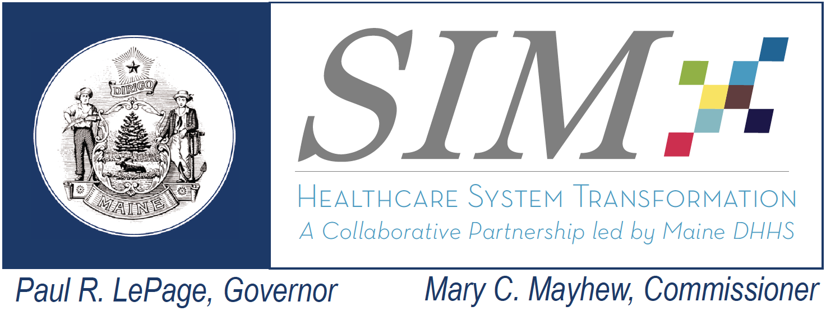 |  | SIM Steering Committee Meeting  December 10, 2014  9:00 AM – 12 PM  Bank of Maine Ice Vault - 203 Whitten Rd. Hallowell, ME  Conference Call #: 877-455-0244  Conference Call Code: 2072875013  Webinar Link: https://global.gotomeeting.com/join/325368269
Topic | Lead | Objective and Planned Highlights of Discussion |  | Estimated Time
1-Welcome – Minutes Review and Acceptance | Dr. Flanigan | Approve Steering Committee minutes from October Steering Committee meeting |  | 10 mins  9 – 9:10
2-Determining the need for development of a Statewide data interoperability roadmap | Dr. Flanigan | Introduce the topic to the Steering Committee of utilizing the SIM Governance structure to develop a Statewide data interoperability roadmap for recommendation to State leadership |  | 10 mins  9:10-9:20
3- The Lewin Group – Update and overview of SIM Core Metric Dashboard example | David Hanig, Lewin Team | Lewin presentation will include highlights of their evaluation plan for Maine’s SIM grants as well as a providing an example of the SIM core metric dashboard |  | 30 - 45 mins  9:20 – 10:05
Break – 15 minutes (10:05 - 10:15)
4-Meaningful Consumer Involvement Presentation | Cathy Bustin, Lydia Richard | Meaningful Consumer Involvement Presentation: Overview presentation from consumer advocates regarding the importance of Meaningful Consumer involvement throughout SIM and other healthcare transformation work |  | 30 mins  10:15 – 10:45
5 – Care Coordination (Risk 21) | Lisa Tuttle/Katie Sendze/Frank Johnson |  | Update on plans developed to address the Care Coordination risk by SIM Subcommittee chairs | 10:45 – 11:10
6- Core Measure Set development Update | Ellen Schneiter |  | Update on the Core Measure set work being completed under the supervision of the Payment Reform subcommittee | 11:10 – 11:20
7 – Subcommittee Report Questions from the Steering Committee | All |  | Standing agenda item – Allocate time to allow Steering Committee members to ask SIM subcommittee chair about content in any of the subcommittee reports | 11:20 – 11:40
8 - Steering Committee Risk or Issue identification and review | Dr Flanigan |  | Standing agenda item - Allocate time for Steering Committee members to identify risks or issues to SIM Risk and Issue log | As needed
9 - Public Comment |  |  |  | 10 mins  To begin no later than 11:50

